Day - 23  
  
Name - Rishabh Manchanda

Employee ID:

109883998

Task 01

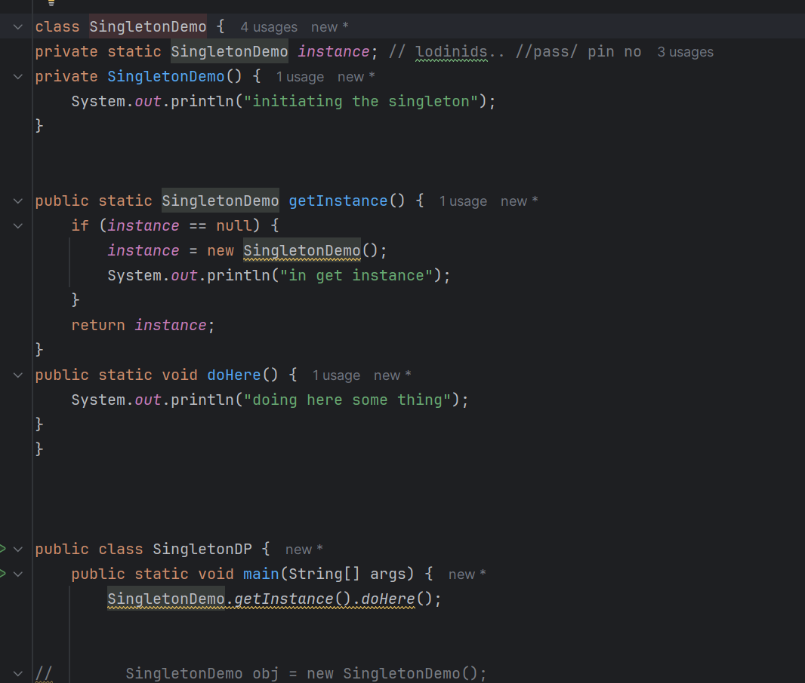

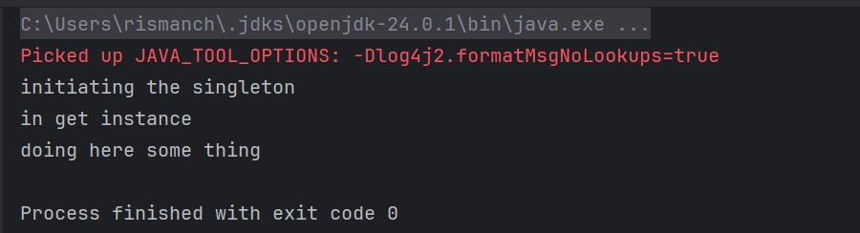

Task 02

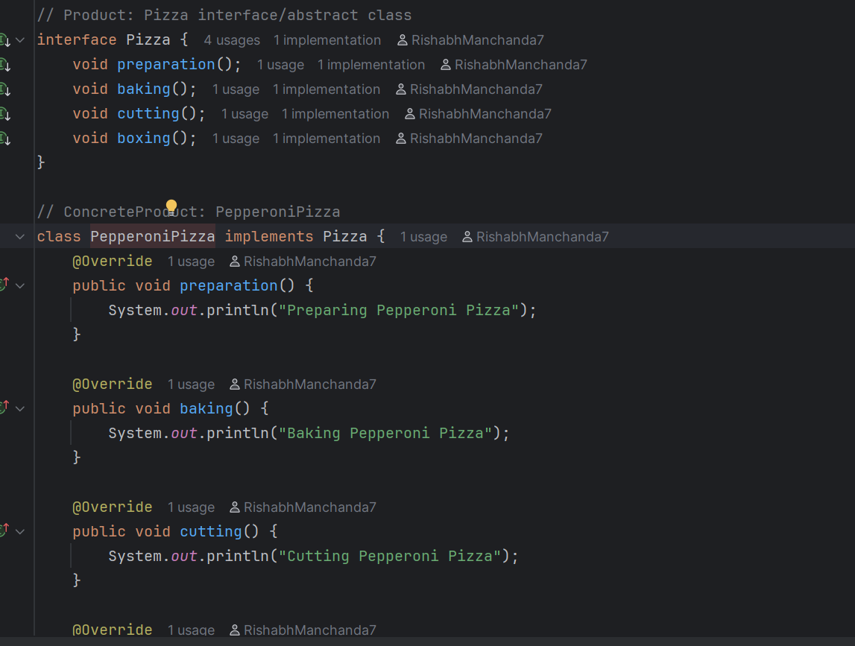

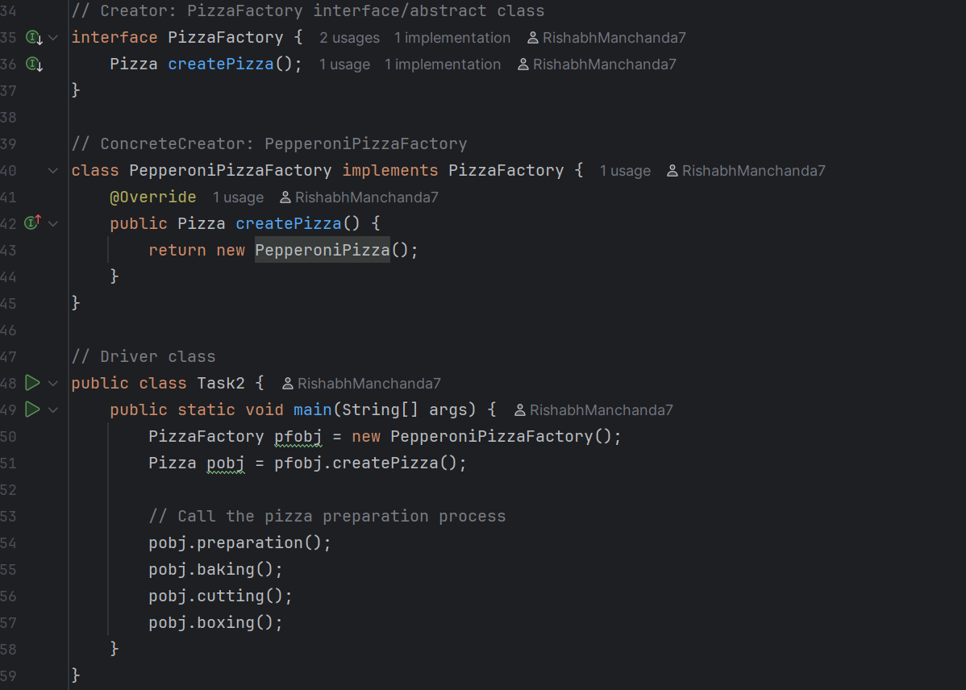

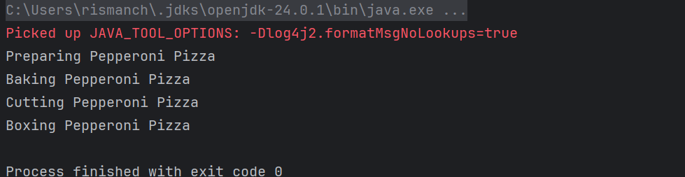

**Design patters:**

1. Creational Design Patterns:

types of Creational design Patterns:

1. Factory Method
2. Singleton Method
3. Abstract Factory Method
4. Builder Method
5. Prototype Method

@startuml

participant Pax as p

actor Actor as a #Green

boundary Boundary as b

control C as c

database Dbase as db

entity table as t

collections col as c

queue que as q

autonumber

p -[#red]> a : pax to actor

a ->x p: ohh is it!

autonumber 100

b ->> p: boundary to pax

note left: plz make a note on left

c -\ p: control to pax

db \\- p: db to pax

autonumber 50 10

t //-- db: table to db

c ->o db: collection to db

note right: plz make a note

q <->o p: q to pax

Prasunamba -> Batch1 : learning uml

Batch1 -> Prasunamba: ok will learn

@enduml